Name:_________________

Date:__________________

**Warm up 3.2 SHOW YOUR WORK!!!**

Solve the following problems by hand, use graphing calculator to check:

1. Use the Leading Coefficient Test to determine the end behavior of the graph of the given polynomial function (HINT: Find the dominant term, decide if *n* is even/odd and what this implies, and decide if *a* is > or < than 0 and what this implies): 
2. Find the zeros of the given polynomial function and give their multiplicity. State whether the graph crosses the x-axis or touches the *x*-axis and turns around at each zero: 
3. 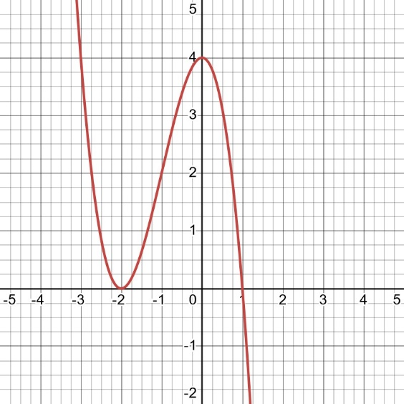

a) Find the zeros and state whether the multiplicity of each zero is even or odd.

b) Write an equation, expressed as the product of factors, of a polynomial function that might have the graph. Use a leading coefficient of 1 or -1 and make the degree of f as small as possible.